Tohickon’s Parent Survival Guide
Office hours are 7:00 AM to 3:00 PM

- Parents should notify the school as early as possible regarding absence, lateness, doctor's appointments, etc. by logging into the parent portal and entering the absence. 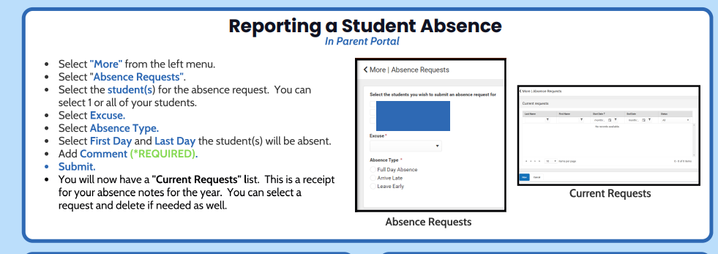
You may also call the attendance line on 267-893-3305. Any time a student arrives to school late, they must bring a parent note in with them explaining why they are late or a parent needs to enter it in the parent portal. Any late arrival without a note will be marked as unexcused.

- After 7:30 AM, a student is tardy. Students must report to the office for attendance accounting when arriving late. Such reasons as missing the bus, oversleeping, car trouble, long drop off line, etc. are not valid excuses for lateness. Every unexcused lateness, from the third time (and all succeeding times), will result in an administrative consequence. Late time may be accumulated and count toward illegal absences from school. Unexcused lateness in excess of half the school day will be considered an unlawful absence.

- Appointments during the School Day: Students may be excused for short periods of time during the day for medical appointments. A note from parents should be taken to the office prior to the start of the school day on the day of the appointment. If the time involved is early morning, a parent should enter this in the portal before 8:00 AM or call the office. Parents/guardians must pick up students in the office. In order to take part in any after-school event (including dances and games), students must attend school for at least half of that day. At the middle/high school levels, students need to report to school by 10:30 AM.

- Lockers: Lockers will be provided to all students this year. Students will not be permitted to carry backpacks during the day, so the use of the lockers will become an important space for storage.

- Whenever a student needs to leave school before 2:30, parents are asked to enter the dismissal time in the parent portal before 8:00 AM or the student must bring a note from a parent to the main office upon arriving at school. They will receive a pass to leave class, which must be turned into the office before being dismissed for their appointment. Parents must come to the office to pick up their child. If possible, inform the office in advance if you get a last-minute appointment so that we can advise the student who can leave class quietly, without the disruption of calling into a classroom.

- Homework may be requested after the student has missed three consecutive instructional days (snow days and weekends do NOT count). If the request is received by 8:30 AM, it will be available for a parent to pick up in the main office before 3:00 PM the same day. Most teachers now post the classwork and homework on their teacher websites which can be accessed from the Tohickon website. If your child has not been out for three days or if a teacher did not collect work for them, please check e-notes. Students should also have a “study-buddy” in each class to call to find out what assignments are missed.

- In accordance with Central Bucks Transportation policy, students will not be permitted to travel on another student’s bus. Requests to travel on another student’s bus will not be approved. Only in an extreme emergency (parent travel is NOT considered an emergency) will requests for alternate transportation be granted.

- When visiting Tohickon, please come prepared to show photo ID. All visitors are required to enter and leave through the main office, sign in and wear a visitor’s badge while in the building.

- The use of cell phones/electronic devices during the school day is prohibited. All cell phones/electronic devices should be in the “power off” position and kept out of sight during school hours. It is recommended that students keep cell phones/electronic devices in lockers. The use of electronic imaging devices associated with cell phones/electronic devices, or any similar type of communications technology is strictly prohibited at all times.

- If the school nurse determines that your student should be sent home due to illness or injury, she will contact a parent/guardian directly. Students are not permitted to call their parent/guardian for pick up in these cases (i.e. use of cell phone.) If you receive a text or call from your child that they are sick, please direct them to go to the nurse. It is up to the nurse to determine if a student is ill enough to go home from school.

- If a lesson requires the use of an electronic device, the teacher will provide students with an opportunity to obtain and return their device from their locker. Under no circumstances are cell phones allowed to be carried from class to class. Students found with their phones or mp3 devices will have to turn them into the main office. The first time, the items may be picked up in the main office at 2:30 PM.

- Please do not call or text your student during the school day. If you need to get a message to your student, please call the main office.

- Please make sure your student’s name is on items they may bring to school. We have many sweatshirts, coats and lunchboxes in our lost and found, which is located in the back of the cafeteria and in large red totes placed on each floor. If items are identifiable, they will be returned to students. If not, students and parents are urged to check lost and found. At the end of the marking period, items are donated to charitable organizations.

- Drop-off items (i.e. lunches, homework, sports gear, etc.) are held in the main office and brought to students in the cafeteria at lunch time. They may check the office between classes or before and after lunch. To avoid class disruptions, we do not to call into classrooms or call down students individually for forgotten items.

- Students involved in sports will receive pertinent information from coaches. Announcements are made regarding changes in schedules for games, practices, etc. as provided by the appropriate coach. In order to take part in any after-school event (including dances and games), students must attend school for at least half of that day. At the middle/high school levels, students need to report to school by 10:30 AM.

- Physical forms are available online and must be completed after June 1st of the appropriate school year. Physicals are necessary for any student who wishes to participate in a sport. Students will not be permitted to attend try outs for a sport until physical forms must be turned. Family ID information should also be completed. Instructions can be found under the “Athletics” tab on the Tohickon website. All physicals will need to be submitted through Family ID. We will no longer be accepting paper copies.

